A Spanning Multichannel Linked Hypercube:
A Gradually Scalable Optical Interconnection
Network for Massively Parallel Computing

Ahmed Louri, Senior Member, IEEE, Brent Weech, Student Member, IEEE,
And Costas Neocleous, Student Member, IEEE

- Introduction

Ideally, a network topology intended for massively parallel computing should have the following characteristics:
- small or bounded degree (a small degree implies low design complexity and low cost, a bounded or fixed degree implies scalability and fixed PE complexity)
- ability to incrementally add PEs loan existing network with minimal or no changes at all to the existing configuration,
- a large number of PE-disjoint paths between any two pairs of PEs for increased reliability and fault tolerance,
- the message routing should be simple to implement and flexible to route around faulty PEs in the network,
- the diameter should be small to minimize communication delays,
- must have a large communication bandwidth, and
- must possess good embedding capabilities (ability to efficiently emulate a large number of commonly required interconnection patterns).

Unfortunately, most of the presently known network topologies do not satisfy all the above characteristics.

Hypercube good topological characteristics:
small diameter, regularity, high connectivity, simple control and routine, symmetry, fault tolerance.
Drawback of hypercube:
Lack of scalability, which limits its use in building large size systems out of small size systems. Because the node degree is not bounded and varies as ${\text{log}}_{2}N$, where N is the total number of nodes.

OMMN( Optical Multi-Mesh Hypercube):
Can be viewed as a two-level system: a local connection level representing a set of hypercube and a global connection level representing the mesh network connecting hypercube modules.

SMLH( Spanning Multichannel Linked Hypercube )
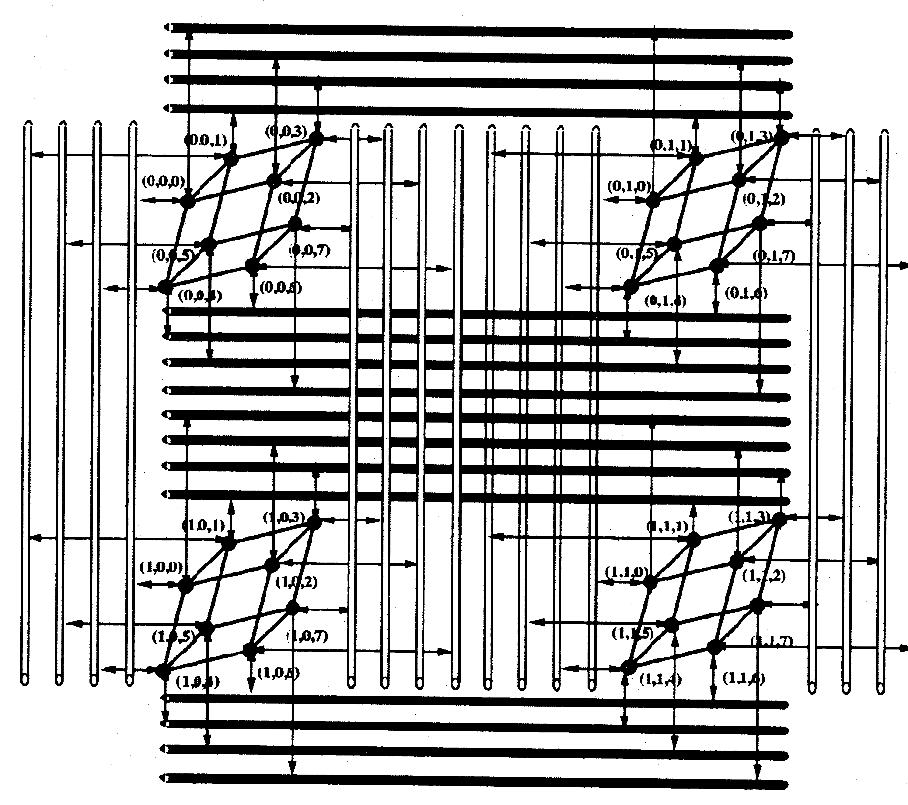
A constant degree and a constant diameter which preseving many properties of the hypercube.
Fig 1. SMLH(w=2,n=3)(32 nodes) is show. Thick lines represent SMN connections, while bold, thin lines represent point-to-point hypercube connections.

- Structure of the SMLH
The SMLH can be characterized by a three-tuple(w, n, D),where w, n and D are positive integers.
w: defines the number of nodes attached to each multichannel link.
n: the degree of the point-to-point n-cube(hypercube).
D: identifies the number of dimensions spanned by a node in the SMN.
The SMLH can be viewed as a product hybrid network combining two subnetworks: a D-dimensional SMN and a hypercube.

SMLH(w, n, D), the number of the nodes, $\left|V\right|$, is equal to $w^{D}2^{n}$. A node address in the SMLH is denoted by a (w+1)-tuple$(a_{1},a_{2},\text{.}\text{.}\text{.},a_{w},a_{w+1})$ using a mixed radix system, where, for $i=1$ to $i=w$,$0≤a_{i}<w$and$0≤a_{w+1}<2^{n}$
Given the set of nodes (V), the set of edges (E) is constructed as follows: For two nodes $(a_{1},a_{2},\text{.}\text{.}\text{.},a_{w},a_{w+1})$ and $(b_{1,}b_{2},\text{.}\text{.}\text{.},b_{w},b_{w+1})$where, for $i=1$ to $i=w$,$0≤a_{i}<w$, for $j=1$ to $j=w$,$0≤b_{j}<w$,$0≤a_{n}<2^{n}$ and$0≤b_{w+1}<2^{n}$
1) The two nodes span the same SMN if
a)$a_{w+1}=b_{w+1}$, and
b) if, for $i=1$ to $i=w$, there are only two components, $a_{j}=b_{j}$, that are different, while all the other components are identical.
2) There is a link (called a hypercube link), between two nodes if and only if, for $i=1$ to $i=w$
- $a_{i}=b_{i}$, and
- $a_{w+1}$and$b_{w+1}$ differ by one bit position in their binary representation (Hamming distance of one).

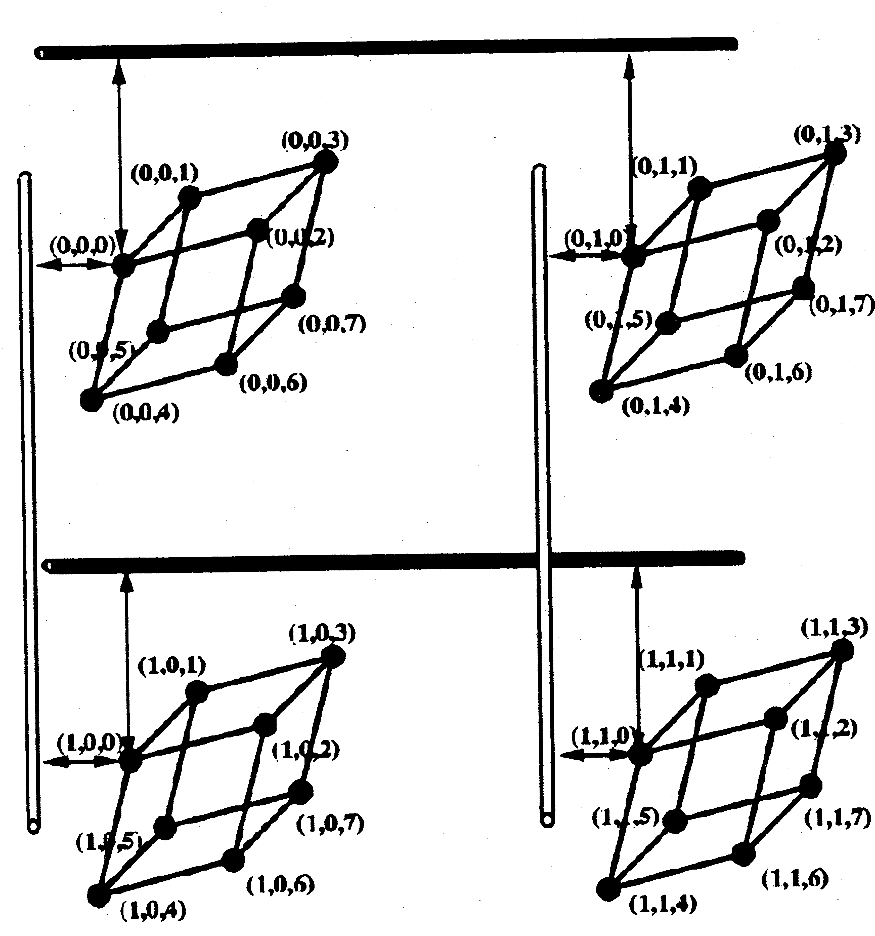
In this paper, we only consider SMLH networks with D=2 and leave higher dimensioned SMLH network. In general, there are $2^{n}$ 2D SMNS and $w^{2}$ hypercube modules. Note that when w=1, the SMLH becomes a pure hypercube network, while n=0, it becomes a pure spanning bus network if the multichannel link is constrained to operate on a single channel.
Fig2. An example of a 2D SMN eithin an SMHL(w=2, n=3) network. Note that the nodes that construct the 2D sMN belong to different hypercube modules but they posses the same binary hypercube address,

Properties of the SMLH interconnection Network

1.Diameter

The diameter of a 2D SMN is 2.
The diameter of SMLH(w,n) is(n+2)
Total nodes N=$w^{2}2^{n}$, n=${\text{log}}_{2}\frac{N}{w^{2}}$ so,
The diameter of SMLH can be written as ${\text{log}}_{2}\frac{N}{w^{2}}$+2,
Fixed w, the diameter increases O(${\text{log}}_{2}\frac{N}{w^{2}}$)
However fixed n, the diameter constant, n+2

2.Bisection Width

the bisection width of a network is defined as the minimum number of links that have to be removed to partition the network into two equal halves.
The bisection width of n-cube is $2^{n−1}$
The equation of bisection width for the SMLH varies depending on whether w is even or odd, since w odd dictates cutting at least one hypercube in half.
Even=>$w×2^{n}=N/w$
Odd=>$w×2^{n}+2^{n}+2^{n−1}=N/w+3N/2w^{2}$

- Average Message Distance

The averege distance $\overline{l}=\frac{1}{N−1}\sum_{i=1}^{n}{{\text{iN}}_{i}}$
$${\overline{l}}_{\text{SMLH}}=\frac{2w(w−1)+n2^{n−1}}{(w^{2}−1)+(2^{n}−1)}$$

3.Comparisons of SMLH with popular networks
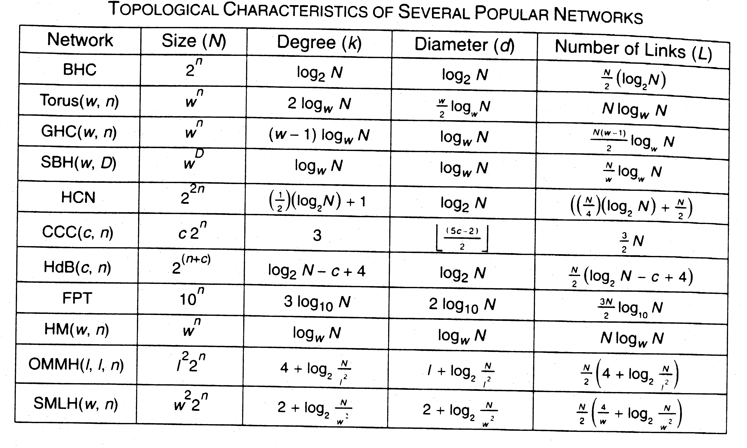

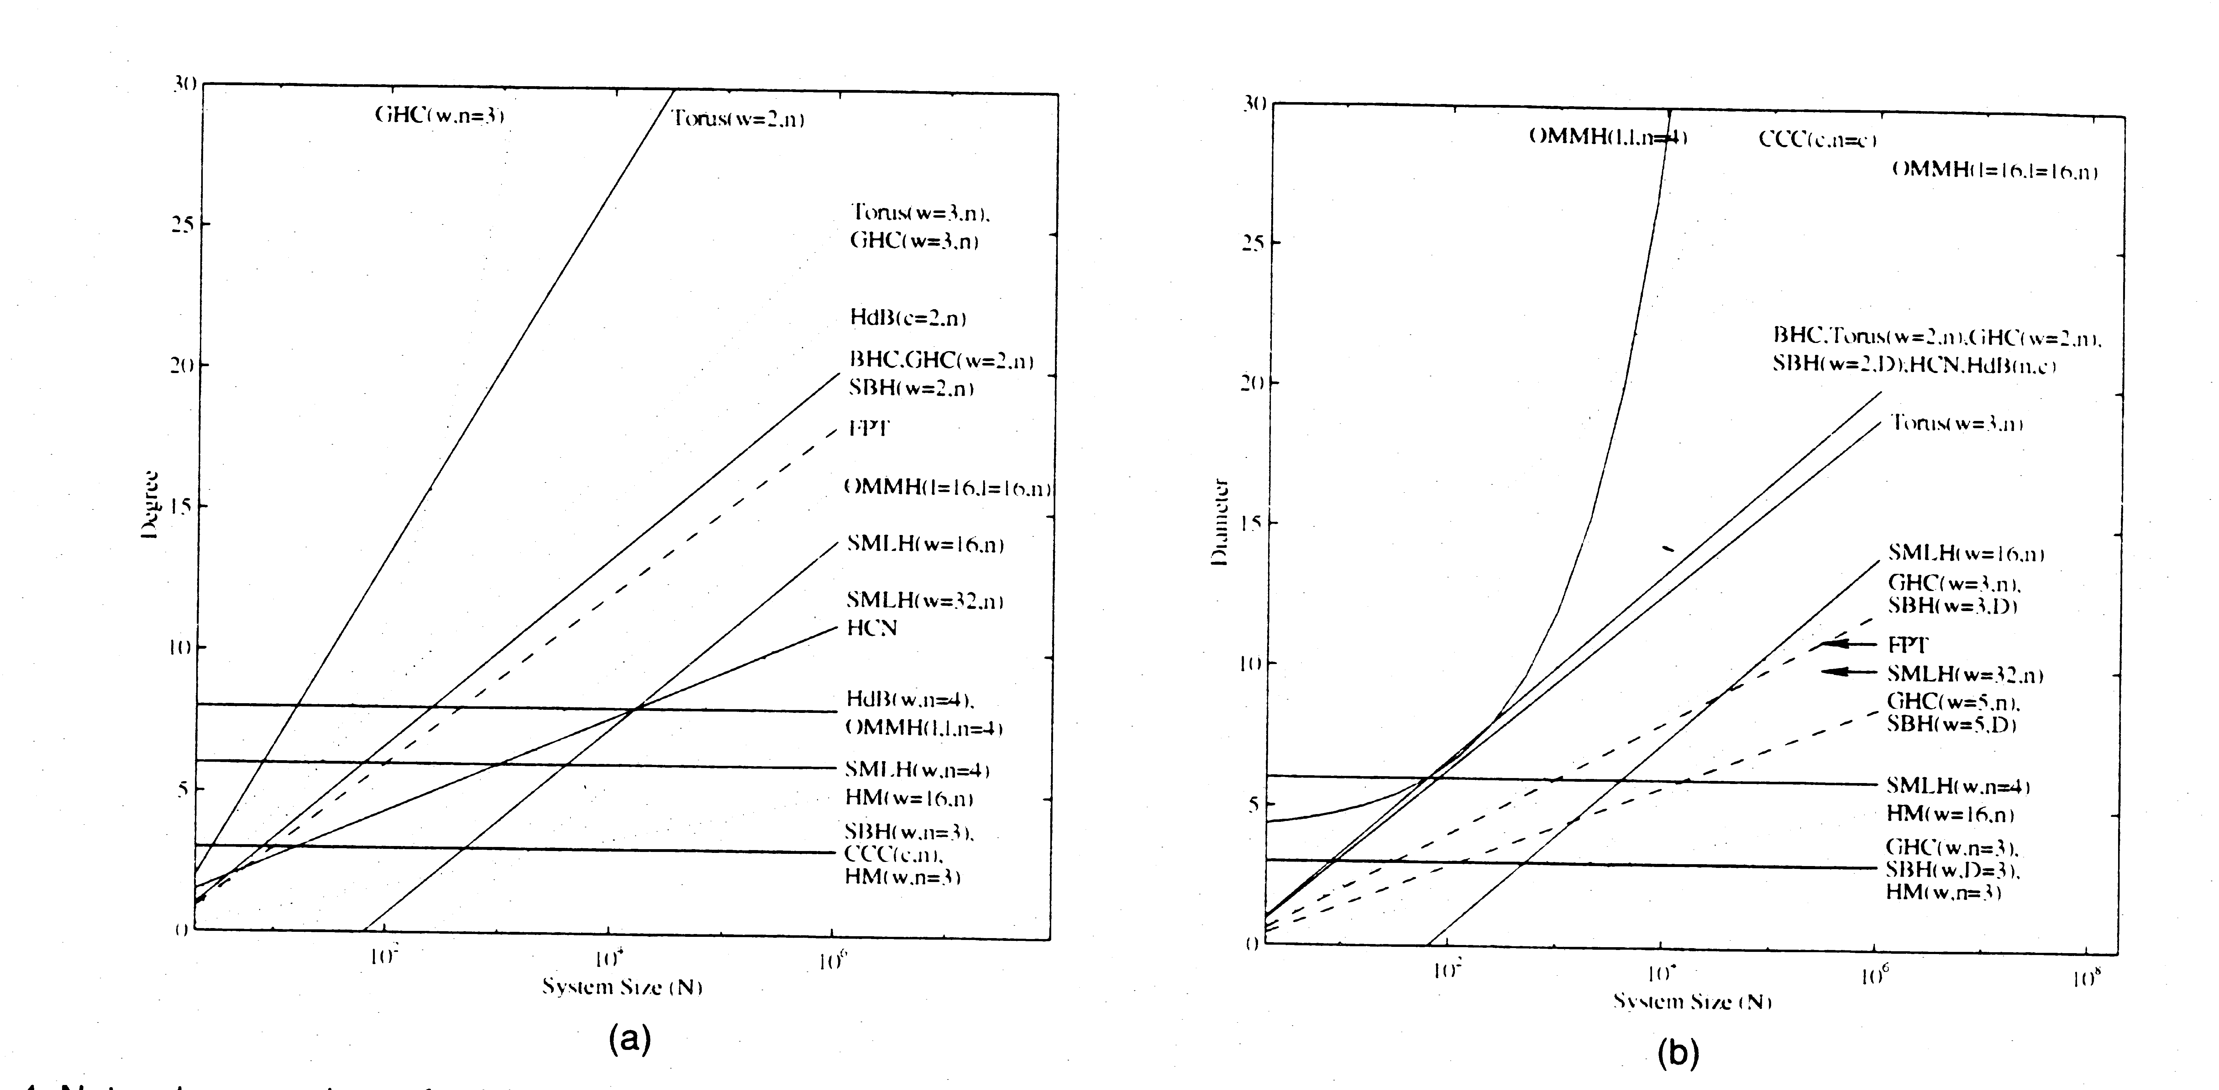

4.Optical Implementation of this SMLH network

Obviously, an electronic implement of the proposed SMLH network is feasible. But it has major limitations. These include signal skew, wave reflection, impedance mismatch, skin effects, interference, and many others. A possible alternative is the use of optical interconnects.
Advantages of optical interconnects: gigahertz transfer rates, high interconnection density, low power requirements, a significant reduction in design complexity .

Optical Implementation of the Hypercube Modules Using Holographic Optical Elements(HOES)

The design methodology is based on an observation that PEs in a bipartite interconnection network can be partitioned into two different sets of PEs such that any two PEs in a set do not have a direct link.

Besides bipartitioning the graph, we arrange the PEs in each partition onto the plane such that interconnection between two planes becomes space-invariant.
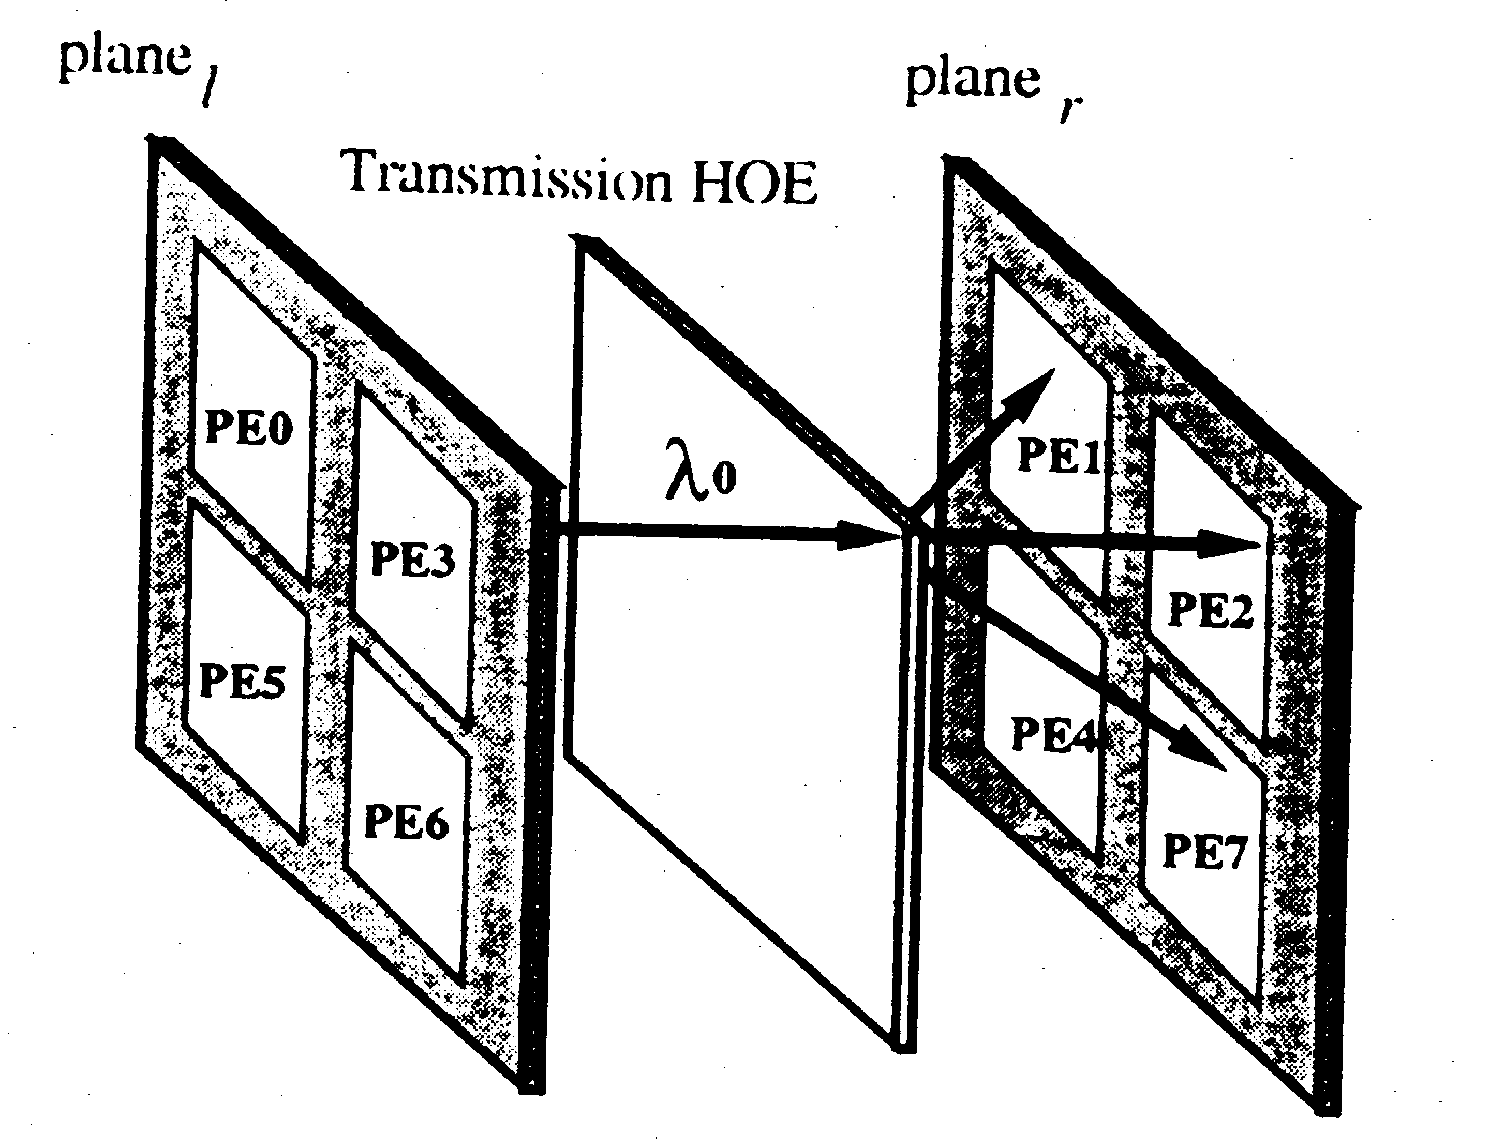
Fig 8. Space-invariant optical implementation of a three-cube network with a HOE

Implementation of the SMLH Using WDMA techniques

Wavelength Division Multiple Access(WDMA)

To exploit the large communication bandwidth of optics, WDMA techniques that enable multiple multiaccess channels to be realized on a single physical channel can be utilized. In a WDMA system, the optical spectrum is divided into many different logical channels, each channel corresponding to a unique wavelength.

The SMLH(w,n) network consists of$w^{2}$ hypercubes modules and
$2^{n}$ 2D SMNs. In the SMLH network, every hypercube module is bipartitioned into two plane called ${\text{plane}}_{l}$and${\text{plane}}_{r}$, all ${\text{plane}}_{l}$ are group together to form a plane called ${\text{plane}}_{L}$, all ${\text{plane}}_{r}$ are group together to form a plane called ${\text{plane}}_{R}$.
$2^{n−1}$ 2D SMNs per Plane(${\text{plane}}_{L}$and${\text{plane}}_{R}$) need to implemented.
Each 2D SMN consists of 2w multichannel links, therefore, a total of $2^{n−1}×2w$ multichannel links per Plane are required.
A trivial implementation of the SMN is to assign a distinct wavelength for every PE in ${\text{plane}}_{L}$ and ${\text{plane}}_{R}$and then
perform WDMA techniques to implement the multichannel
links. However, such a straightforward method requires a
prohibitively large number of different wavelengths and
fibers. For example, for an SMLH(w = 4, n = 3) consisting of
128 PEs, a total of 64 wavelengths would be necessary.
A wavelength assignment technique can be employed to reduce the number of wavelengths used in the system.

Example:
The first row:$λ_{1},λ_{2},\text{.}\text{.}\text{.},λ_{8}$. Then $λ_{2},λ_{3},\text{.}\text{.}\text{.},λ_{8},λ_{ }$are assigned in the second row.
So, the total number of wavelengths required to implement the SMLH(w=4,n=3) network is reduced from 64 to 8.

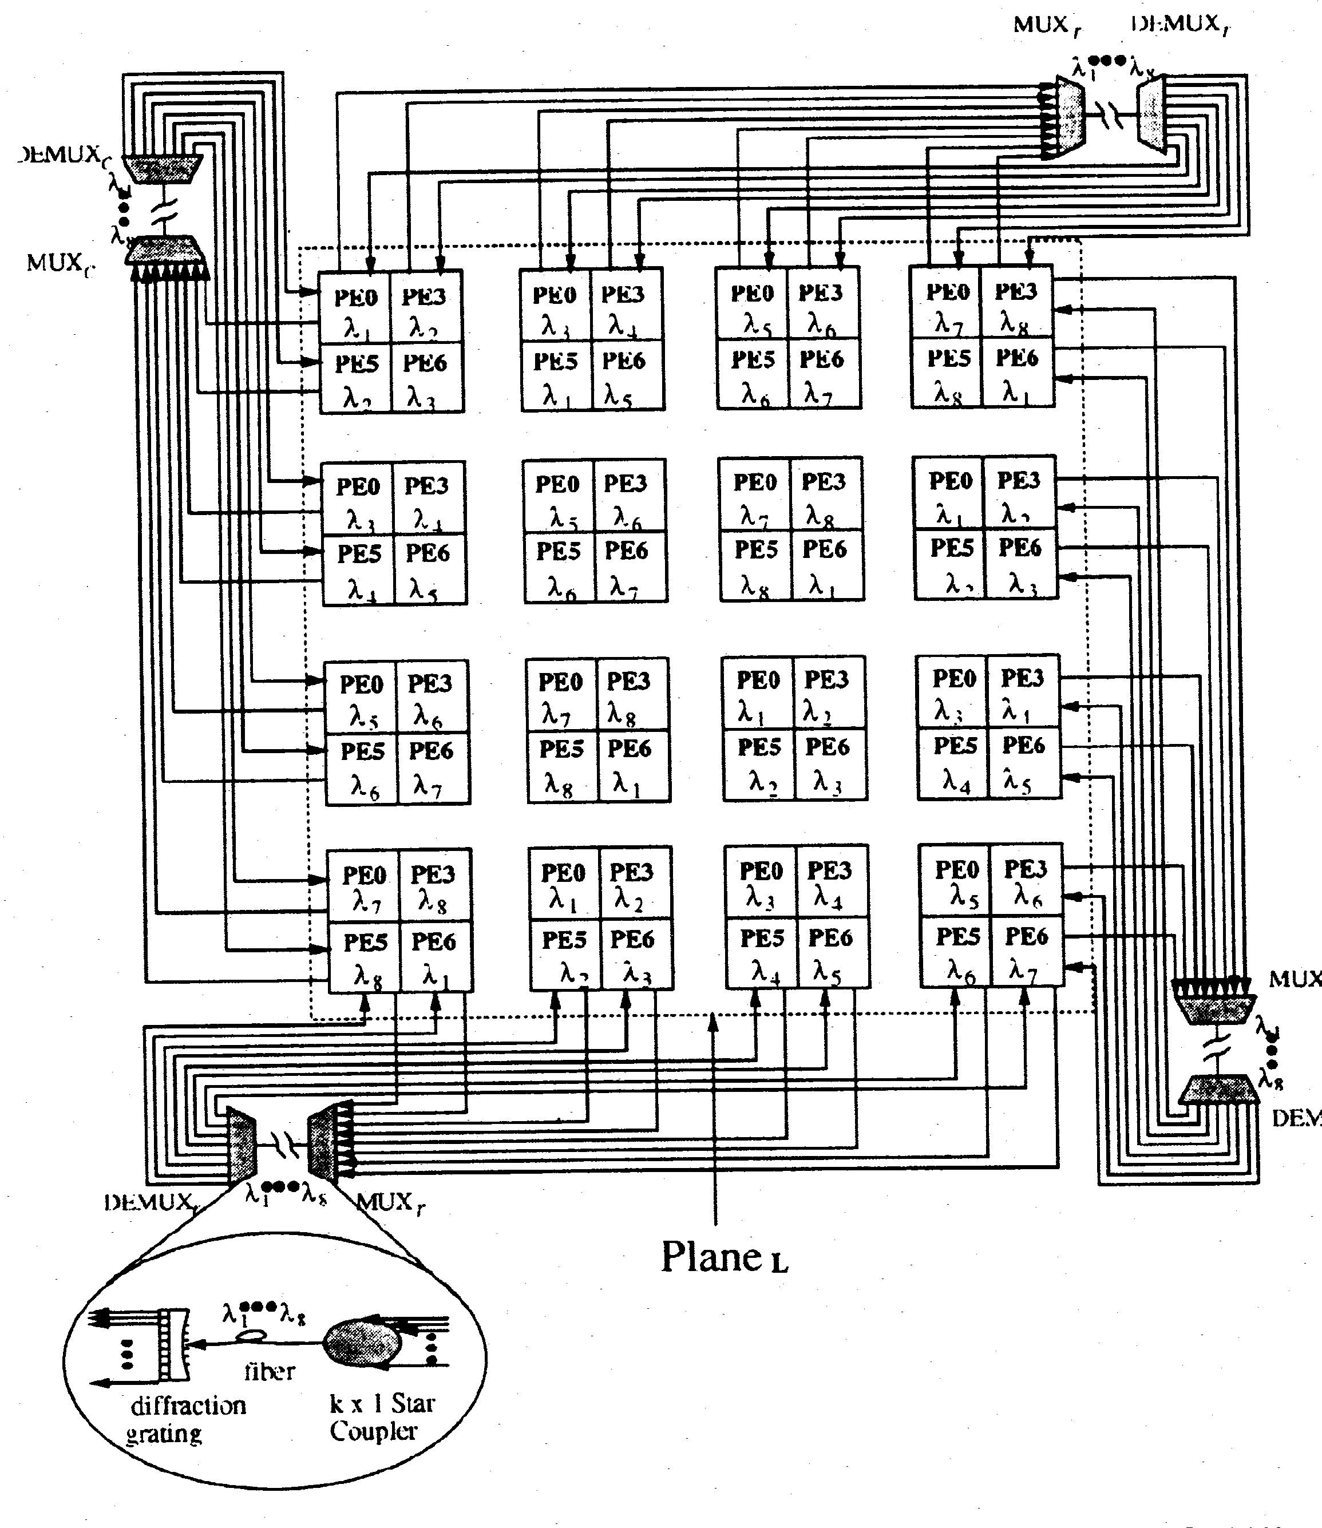
In general, for an SMLH(w, n) the following wavelength assignment for the first row must be performed: $λ_{1},λ_{2},\text{.}\text{.}\text{.},λ_{w×2^{\left\lceil (n−1)/2\right\rceil }}$and then,$λ_{2},\text{.}\text{.}\text{.},λ_{w×2^{\left\lceil (n−1)/2\right\rceil }},λ_{1}$, are the second row and so on. Thus an implementation of an SMLH(w, n) with the above wavelength assignment requires no more than $w×2^{\left\lceil (n−1)/2\right\rceil }$ wavelengths.

